

|  |  |  |  |  |  |
| --- | --- | --- | --- | --- | --- |
| Programme | : | **M.Tech. (Integrated) Software Engineering** | Semester | : | **Fall 20-21** |
| Course | : | **Advanced Database Management Systems** | Code | : | **SWE2014** |
| Faculty | : | **Dr.Bhuvaneswari A** | Slot | : | **L27 + L28** |
| Date | : | **13-10-2020** | Marks | : | **5 Points** |

K.NAVEEN KUMAR

17MIS1056

**Exercise 10 : Sequence Generation**

Consider the following schema for customer-sale, where the primary keys are underlined.

* Customer (**Custid : Integer**, first_name: VARCHAR2, last_name: VARCHAR2, gender : char, email : VARCHAR2 NOT NULL, dob : DATE NOT NULL)
* Item(**Item_id: Integer**, item_name: VARCHAR2, price: integer)
* Sale(**bill_No: Integer**, bill_date: Date, **Custid : Integer, Item_id: Integer**, qty_sold: Integer)

1. First create tables with the primary Key constraints (Underlined attributes are primary keys )

ANS:

create table Customer(

Cust_id integer Primary key,

first_name varchar2(50),

last_name varchar2(50),

gender char(1),

email varchar2(20) not null,

DOB date not null);

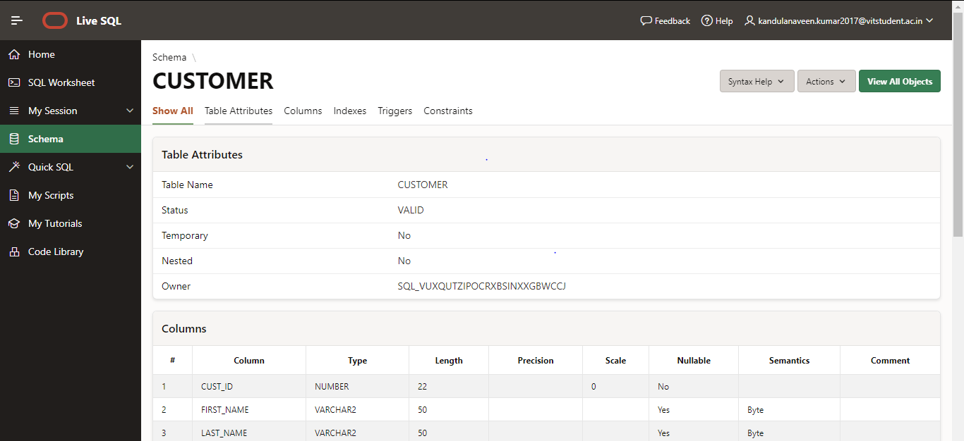

create table Item(

Item_id integer primary key,

Item_name varchar2(30),

price integer);

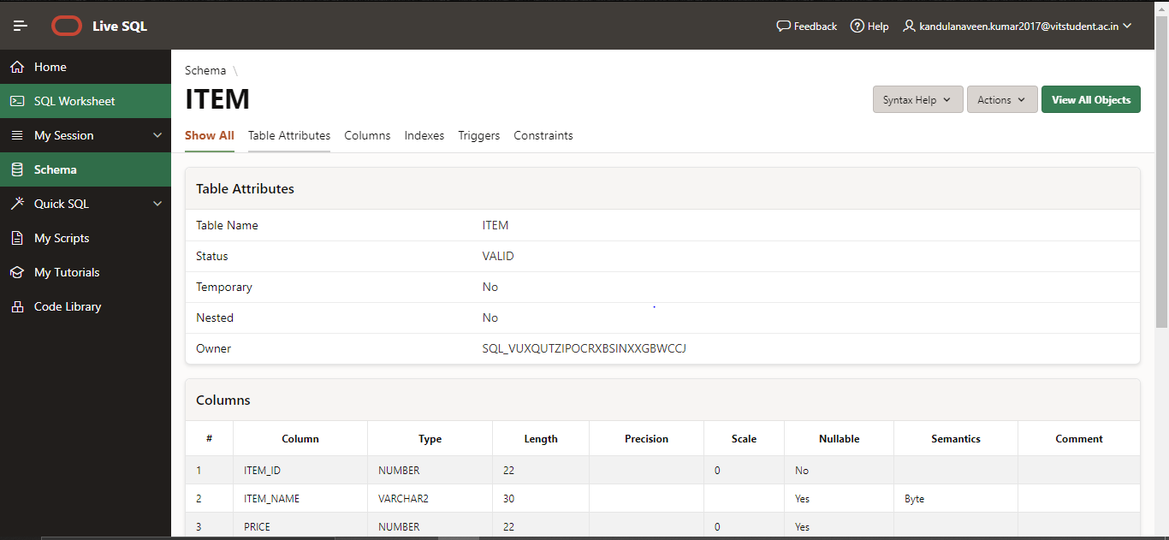

1. Add the Foreign Keys wherever it is applicable.

ANS:

create table Sale(

BillNo integer primary key,

BillDate date,

Cust_id integer,

Item_id integer,

quantity_sold integer,

foreign key(Cust_id) references Customer(Cust_id),

foreign key(Item_id) references Item(Item_id));

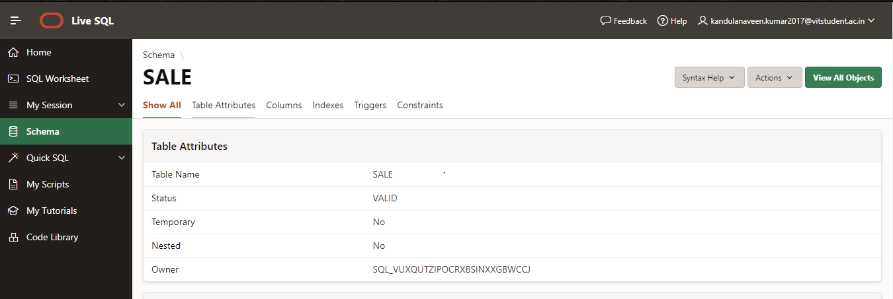

1. Make Customer ID as sequence field start from 1(min) to NO MAX VALUE with auto increment value 1 with Cycle.

ANS:

create sequence Cust_id

increment by 1

start with 1

nomaxvalue

nocycle

nocache;

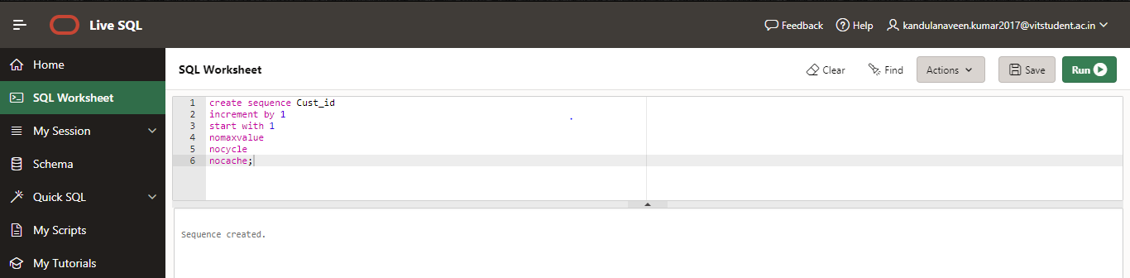

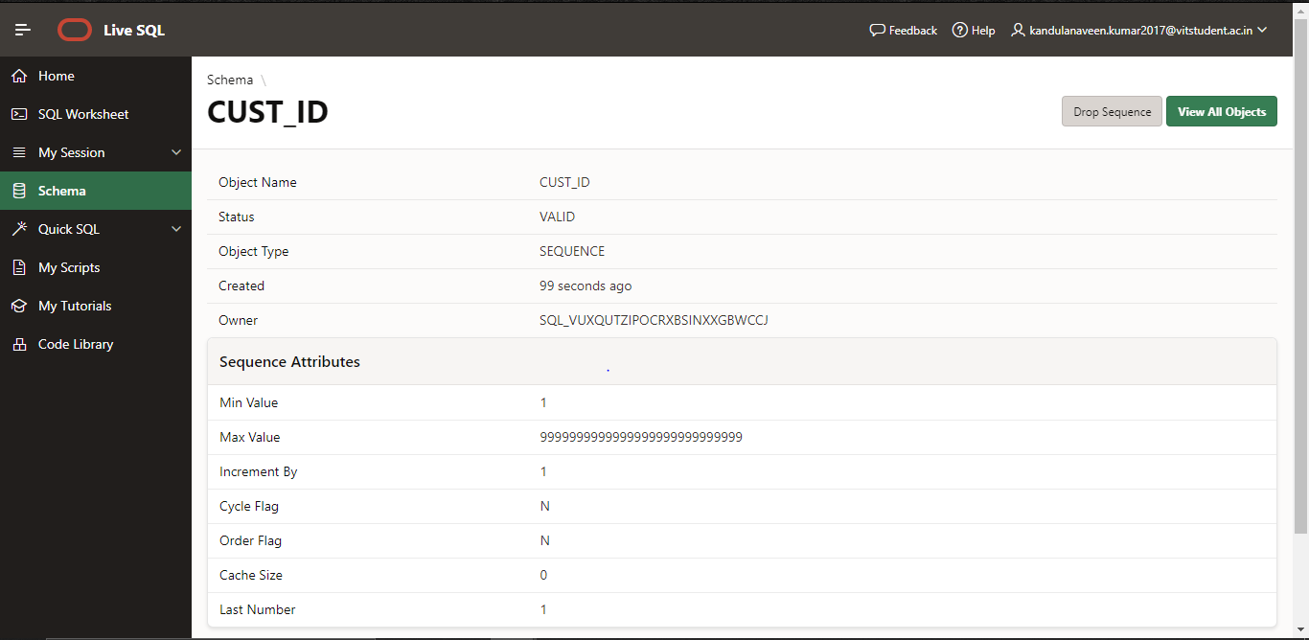

1. Make Item ID as sequence field start from 1001(min) to 2000 (max) with auto increment value 5 with NO CYCLE

ANS:

create sequence Item_id

increment by 5

minvalue 1001

maxvalue 2000

nocycle

nocache;

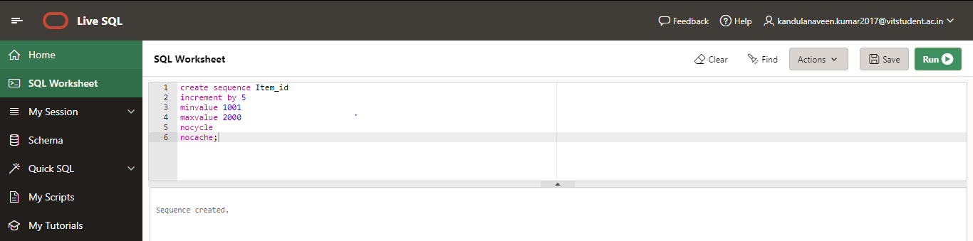

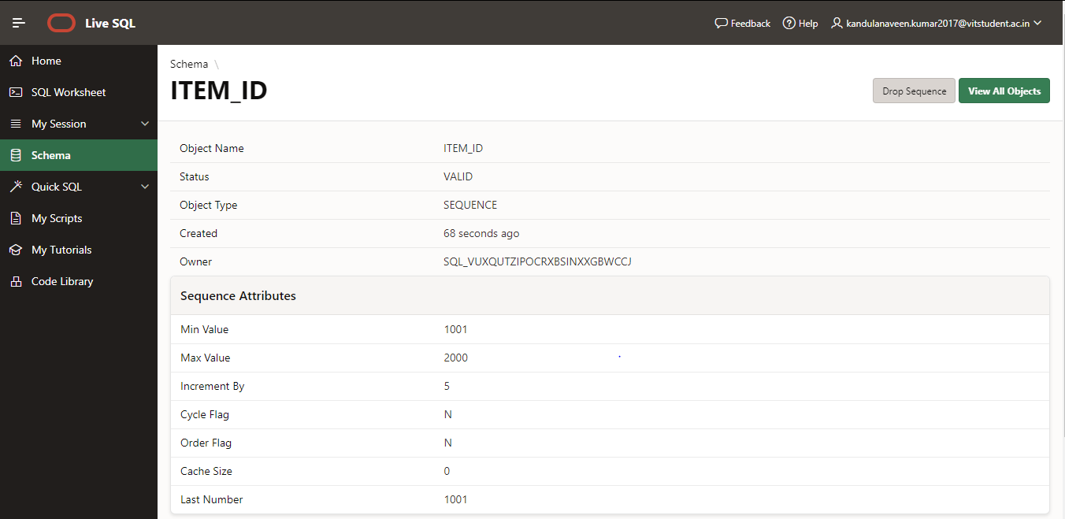

1. Make Sales table Bill_No as Sequence Field to generate bill number automatically from 2001 to NO MAX VALUE with auto increment 1.

ANS:

create sequence Sales_Bill

increment by 1

minvalue 2001

nomaxvalue

nocycle

nocache;

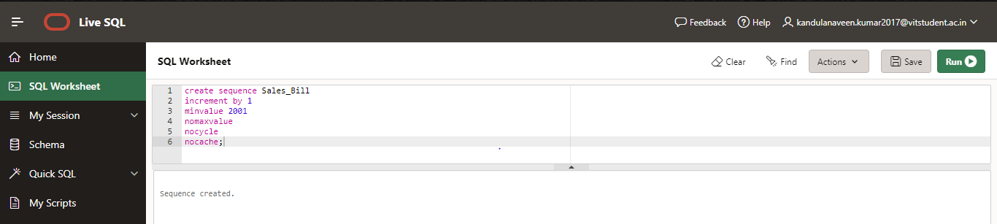

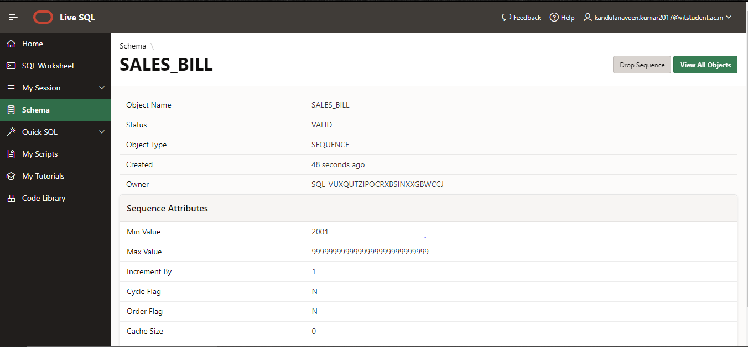

1. Insert values into the tables using sequence.nextval.
2. Perform a record insertion for the sales table using sequence.currval of customer.

Insert into Customer table :

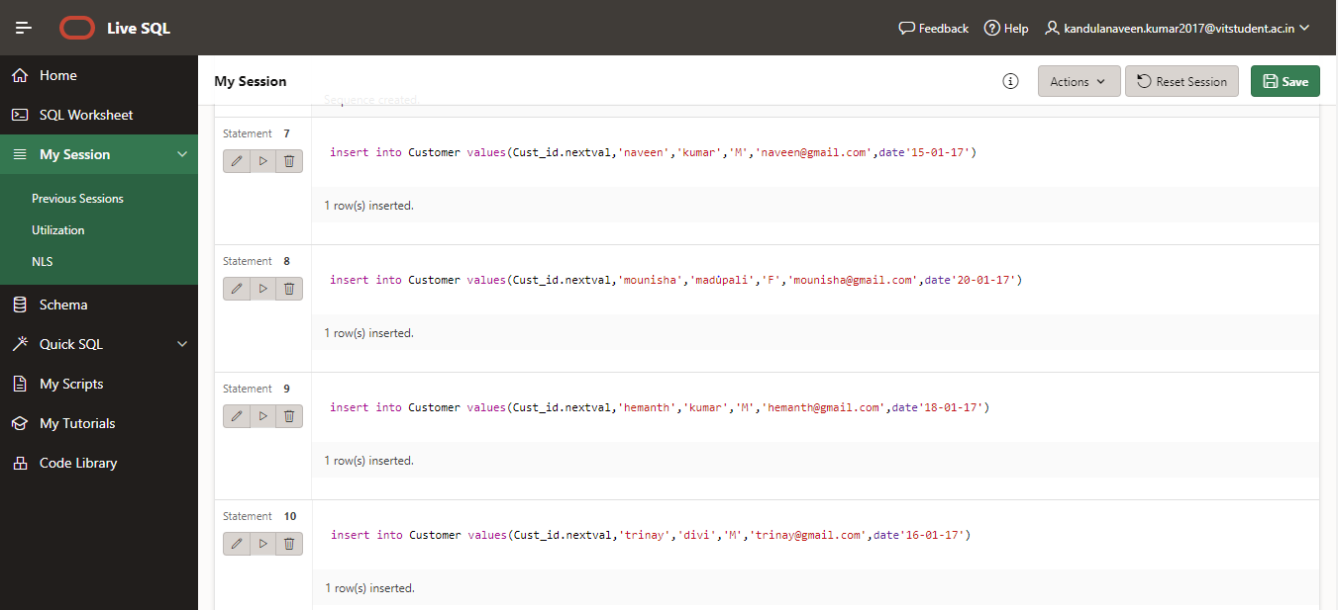

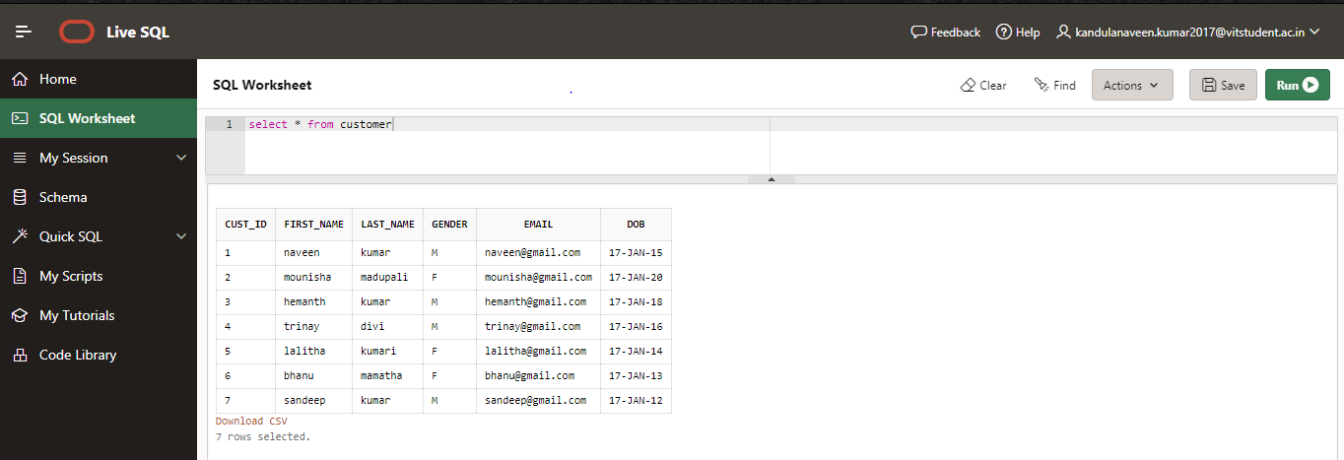

Insert into Items table :

insert into Item values(Item_id.nextval,'iphone','34566');

insert into Item values(Item_id.nextval,'samsung','8664');

insert into Item values(Item_id.nextval,'micromax','57897');

insert into Item values(Item_id.nextval,'poco','75568');

insert into Item values(Item_id.nextval,'oneplus','23456');

insert into Item values(Item_id.nextval,'lava','98765');

insert into Item values(Item_id.nextval,'microsoft','566783');

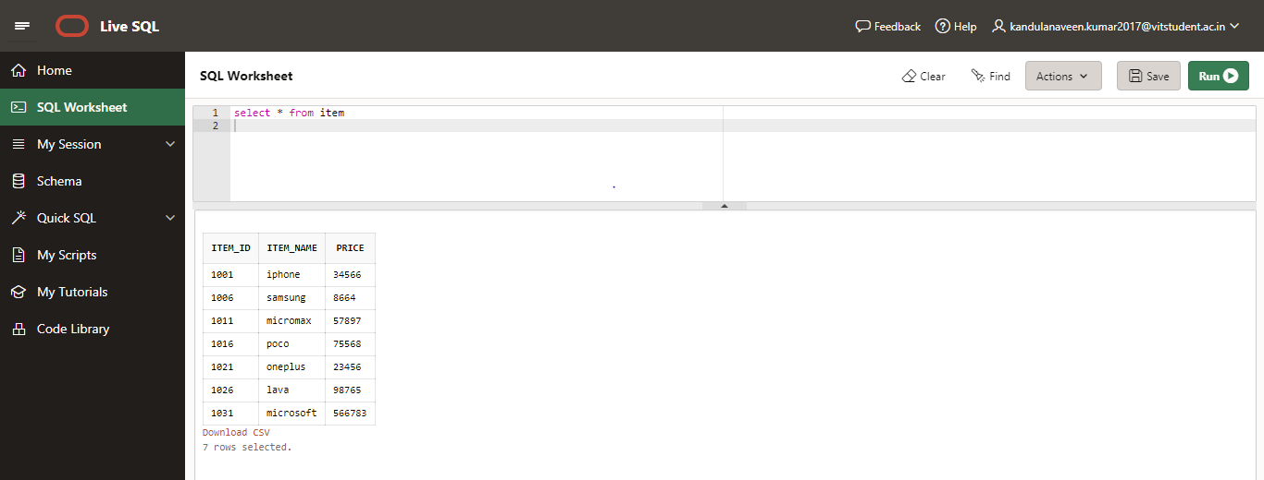

Insert into Sales table :

insert into Sale values(Sales_Bill.nextval,date'12-01-17',Cust_id.currval,Item_id.currval,'20');

insert into Sale values(Sales_Bill.nextval,date'13-01-17',Cust_id.currval,Item_id.currval,'30');

insert into Sale values(Sales_Bill.nextval,date'14-01-17',Cust_id.currval,Item_id.currval,'40');

insert into Sale values(Sales_Bill.nextval,date'15-01-17',Cust_id.currval,Item_id.currval,'50');

insert into Sale values(Sales_Bill.nextval,date'16-01-17',Cust_id.currval,Item_id.currval,'60');

insert into Sale values(Sales_Bill.nextval,date'17-01-17',Cust_id.currval,Item_id.currval,'70');

insert into Sale values(Sales_Bill.nextval,date'18-01-17',Cust_id.currval,Item_id.currval,'80');

select * from Sale;

